Prepaid
Classes
MAC
Special Event
New Class / New Class Time
Cancelled Classes
Sun | Mon | Tue | Wed | Thu | Fri | Sat
 |  |  |  | 11/1 | 11/2 | 11/3
MyZone Points  Challenge  Th 11/8 – Th 11/22 | 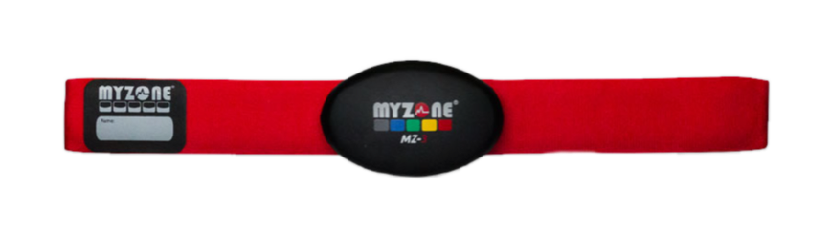 |  |  | 5:00am – Bootcamp  9:00 am – MAC Express  12:00pm – Bootcamp  6:00pm – BARRE  7:15pm – *SPECIAL EVENT*  “Eminem Spin Night” | 5:00am – Small Group Xing  9:00am – Bootcamp  5:30pm – TRX Bootcamp  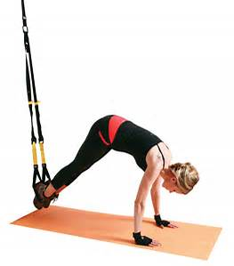 | 8:00am – Spin: Ben  9:15am – Spin/BC Fusion
11/4 | 11/5 | 11/6 | 11/7 | 11/8 | 11/9 | 11/10
9:00am – CycleTone - BARRE  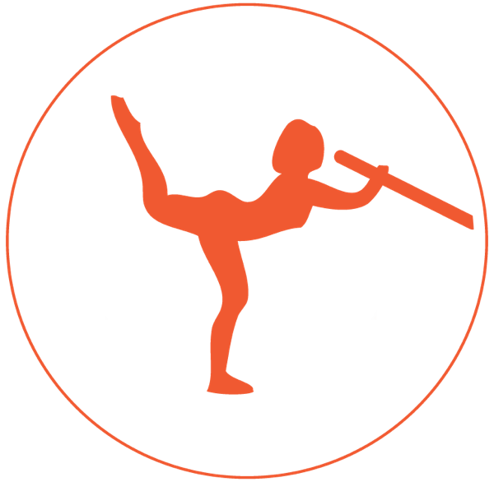 | 5:00am – TRX Strength  9am – Bootcamp  6pm – Spin/BootCamp Fusion | 5:00am – Bootcamp  9:00am - MAC Express  12:00pm – Bootcamp  6:00pm – Vinyasa Flow: Cyndi  7:15pm – Spin/BootCamp Fusion | 5:00am – CycleTone  12:00pm – Bootcamp  5:30pm – MAC Xpress  6:30pm – Pilates: Carol  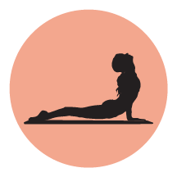 | 5:00am – Bootcamp  9:00 am – MAC Express  12:00pm – Bootcamp  6:00pm – Vinyasa Flow: Cyndi  7:15pm – *SPECIAL EVENT*  “Total Request” Spin Night | 5:00am – Small Group Xing  9:00am – Bootcamp  5:30pm – TRX Bootcamp | 8:00am – Spin: Ben  9:15am – Spin/BC Fusion
11/11 | 11/12 | 11/13 | 11/14 | 11/15 | 11/16 | 11/17
9:00am – CycleTone - BARRE | 5:00am – TRX Strength  9am – Bootcamp  6pm – Spin/BootCamp Fusion | 5:00am – Bootcamp  9:00am - MAC Express  12:00pm – Bootcamp  6:00pm – Vinyasa Flow: Cyndi  7:15pm - Spin/BootCamp Fusion | 5:00am – CycleTone  12:00pm – Bootcamp  5:30pm – MAC Xpress  6:30pm – Pilates: Carol | 5:00am – Bootcamp  9:00 am – MAC Express  12:00pm – Bootcamp  6:00pm – Vinyasa Flow: Cyndi  7:15pm – *SPECIAL EVENT*  “Boy Band” Spin Night | 5:00am – Small Group Xing  9:00am – Bootcamp  5:30pm – TRX Bootcamp | 8:00am – Spin: Ben  9:15am – Spin/BC Fusion
11/18 | 11/19 | 11/20 | 11/21 | 11/22 | 11/23 | 11/24
9:00am – CycleTone - BARRE | 5:00am – TRX Strength  9am – Bootcamp  6pm – Spin/BootCamp Fusion | 5:00am – Bootcamp  9:00am - MAC Express  12:00pm - Bootcamp  6:00pm – Vinyasa Flow: Cyndi  7:15pm – Spin/BootCamp Fusion | 5:00am – CycleTone  12:00pm – Bootcamp  5:30pm – MAC Xpress  6:30pm – Pilates: Carol | 8:00am – Spin/BC Fusion +  Happy Thanksgiving | *ALL CLASSES  CANCELLED* | *ALL CLASSES  CANCELLED*
11/25 | 11/26 | 11/27 | 11/28 | 11/29 | 11/30
*ALL CLASSES  CANCELLED* | 5:00am – TRX Strength  9am – Bootcamp  6pm – Spin/BootCamp Fusion | 5:00am – Bootcamp  9:00am - MAC Express  12:00pm - Bootcamp  6:00pm – Vinyasa Flow: Cyndi  7:15pm – Spin/BootCamp Fusion | 5:00am – CycleTone  12:00pm – Bootcamp  5:30pm – MAC Xpress  6:30pm – Pilates: Carol | 5:00am – Bootcamp  9:00 am – MAC Express  12:00pm – Bootcamp  6:00pm – Vinyasa Flow: Cyndi  7:15pm – *SPECIAL EVENT*  “PRINCE” Spin Night | 5:00am – Small Group Xing  9:00am – Bootcamp  5:30pm – TRX Bootcamp | 8:00am – Spin: Ben  9:15am – Spin/BC Fusion
MAC CLASS DESCRIPTIONS
Questions? Call or text us at (925) 849-7128. Class times subject to change

Bootcamp – MAC Bootcamps are designed to make the most of your time with a variety of different exercises designed to promote cardiovascular activity, increase strength, and lose body fat. This is an awesome workout for those who get bored at the gym or need more support when exercising as you’ll be under the instruction of a certified personal trainer. Each bootcamp consists of a different routing and you may find yourself lifting weights, swinging kettlebells, throwing medicine balls but always meeting great people. All fitness levels welcome.
Time: 60 Minutes
Spin – MAC Spin is a fantastic heart-pumping workout taught on a stationary bike, you will climb, sprint, and train to incredible music and extraordinary instruction. All fitness levels welcome.
Time: 60 Minutes
CycleTone – MAC CycleTone is an amazing total body work that takes place entirely on a stationary bike. Incorporating light weights with high repetitions, you will sculpt your shoulders, chest, back, biceps and triceps while the motion of cycling keeps your heart rate high to burn through more calories. All fitness levels welcome.
Time: 60 Minutes
Disco Spin – MAC Disco Spin puts the “club” in Martinez Athletic Club! An hour of indoor cycling set to the beat of awesome music and disco lighting. You’ll have so much fun you won’t realize how intense your workout is. All fitness levels welcome.
Time: 60 Minutes
MAC Express – MAC Express consists of 30 minutes of spin and 30 minutes of Bootcamp, resulting in maximum results. All fitness levels welcome.
Time: 60 Minutes
SpinBootcamp Fusion – MAC SpinBootcamp Fusion combines the cardio of Spin with the strength training elements of Bootcamp. You will spend the class alternating through Spin intervals of hill climbs, sprints, and flat roads with Bootcamp style exercises done off the bike (think lunges, squats, shoulder presses, and ab work).
Time: 60 Minutes
Level I/II Yoga w/Meditation – MAC Yoga explores the 30 core postures, sun salutes, and introduce breathing techniques; all while improving mental and physical strength, endurance, and increasing flexibility of the spine. This class is perfect for new yogis, those returning to fitness, or the athlete who needs a great stretch! All fitness levels welcome.
Time: 90 Minutes
H2H Yoga Flow (Happy Hips & Hamstrings) – MAC H2H Flow is a special yoga series targeting all muscles attached to the pelvis to result in happy hips and hamstrings. Whether you are a seasoned yogi, weightlifting athlete, or a fitness newbie, this class will help you stretch and strengthen your lower body. This class series runs for the month of January only. All fitness levels welcome.
Time: 75 Minutes
Mat Pilates – This class explores Stott Pilates, which is based on the five basic principles of breathing, pelvic placement, rib cage placement, scapular movement, and cervical placement. In our mat class, we will challenge endurance, balance, and increase flexibility. The result is a longer, leaner, stronger aligned body and focused mind.
Time: 60 Minutes
Theme Ride Thursday – MAC Theme Ride Thursday is a MAC Spin class with a weekly themed ride for everyone. All Fitness levels welcome.
Time: 60 Minutes
Barre – MAC Barre consists of a series of mat work targeting abs and arms. You then will move to the ballet barre where you will unleash the inner ballerina through various exercises targeting your thighs and glutes. The result is a longer, stronger, and more flexible body. All Fitness levels welcome.
Time: 60 Minutes
TRX Strength/Bootcamp – MAC TRX Strength will push you to new levels of strength using the TRX Suspension Trainer and your own body weight. You will move through strength exercises that deliver a high intensity workout sure to burn calories and build muscles.
Time: 60 Minutes
MORE CLASSES ADDED DAILY. PLEASE GO TO www.martinezathleticclub.com FOR UPDATED SCHEDULE.

